

TRW & Presentation

Assignment # 1

Name
Muhammad Faisal
Roll number
2022F-BCS-152
Section
C

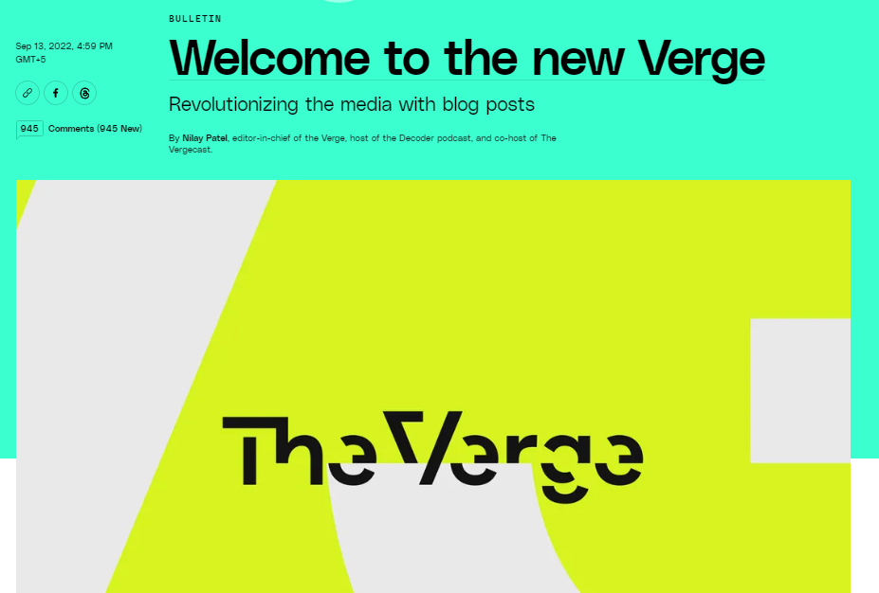
Magazine Title Page


Magazine cover picture

Table of content


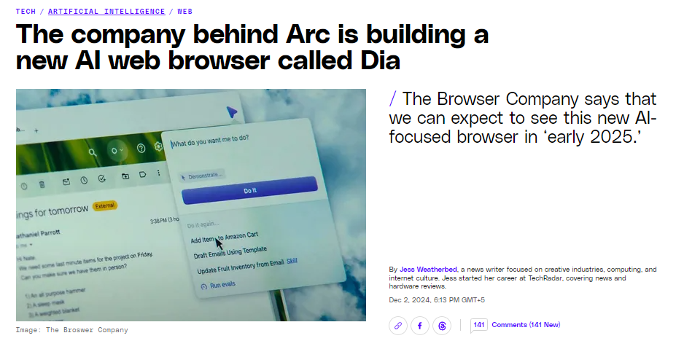

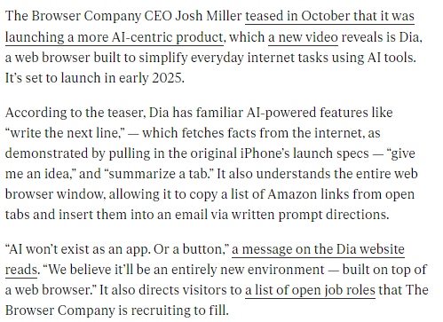

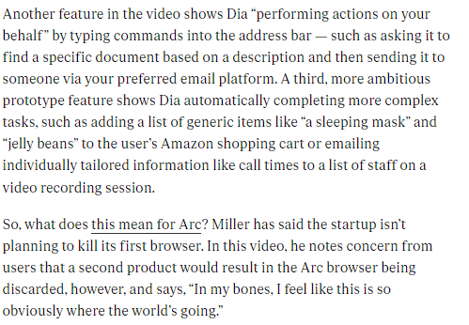

a. Purpose and Intended Audience:
The purpose of this news article is to inform readers about a groundbreaking new product, Dia, which is poised to revolutionize the way we interact with the internet. The intended audience primarily consists of tech enthusiasts, early adopters, and individuals interested in the latest advancements in artificial intelligence and web browser technology.
b. Appealing to Readers:
- Engaging Headline: The headline, "The Browser Company's New AI Browser, Dia, Aims to Simplify the Web," is concise, informative, and intriguing, capturing the reader's attention.
- Clear and Concise Writing: The article is well-written, with clear and concise language that is easy to understand, even for those who may not be tech-savvy.
- Detailed Explanation: The article provides a detailed explanation of Dia's features, including specific examples and screenshots, making it easier for readers to visualize the product's capabilities.
- Future Implications: The article discusses the potential impact of Dia on the future of web browsing, stimulating thought and encouraging further discussion.
c. Appeal Success:
The article effectively appeals to its target audience by providing valuable information about an innovative product. The combination of clear writing, detailed explanations, and future implications makes it an engaging and informative read.
d. Suggestions for Improvement:
While the article is well-written, there are a few areas where it could be improved:
- Visuals: Adding more visuals, such as diagrams or infographics, could further enhance the reader's understanding of Dia's features and how it works.
- User Experience: Discussing the potential user experience of Dia, including its interface and usability, could provide additional insights for readers.
- Ethical Considerations: Addressing the ethical implications of AI-powered browsers, such as privacy concerns and potential biases, could add depth to the article.
e. Stereotypes:
The article does not appear to contain any stereotypes or biases. It focuses on the technical aspects of Dia and its potential impact on the future of web browsing.

